محمد محمد ايمن مسعد مسعد
- Ram, PISO, SIPO, ALU

Ram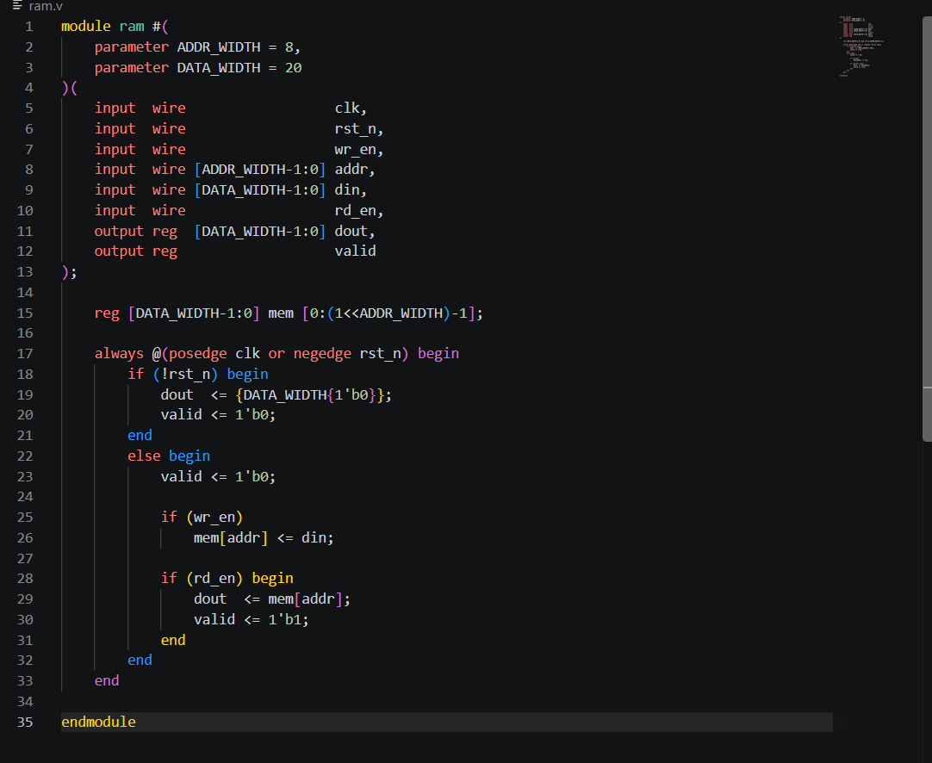
Piso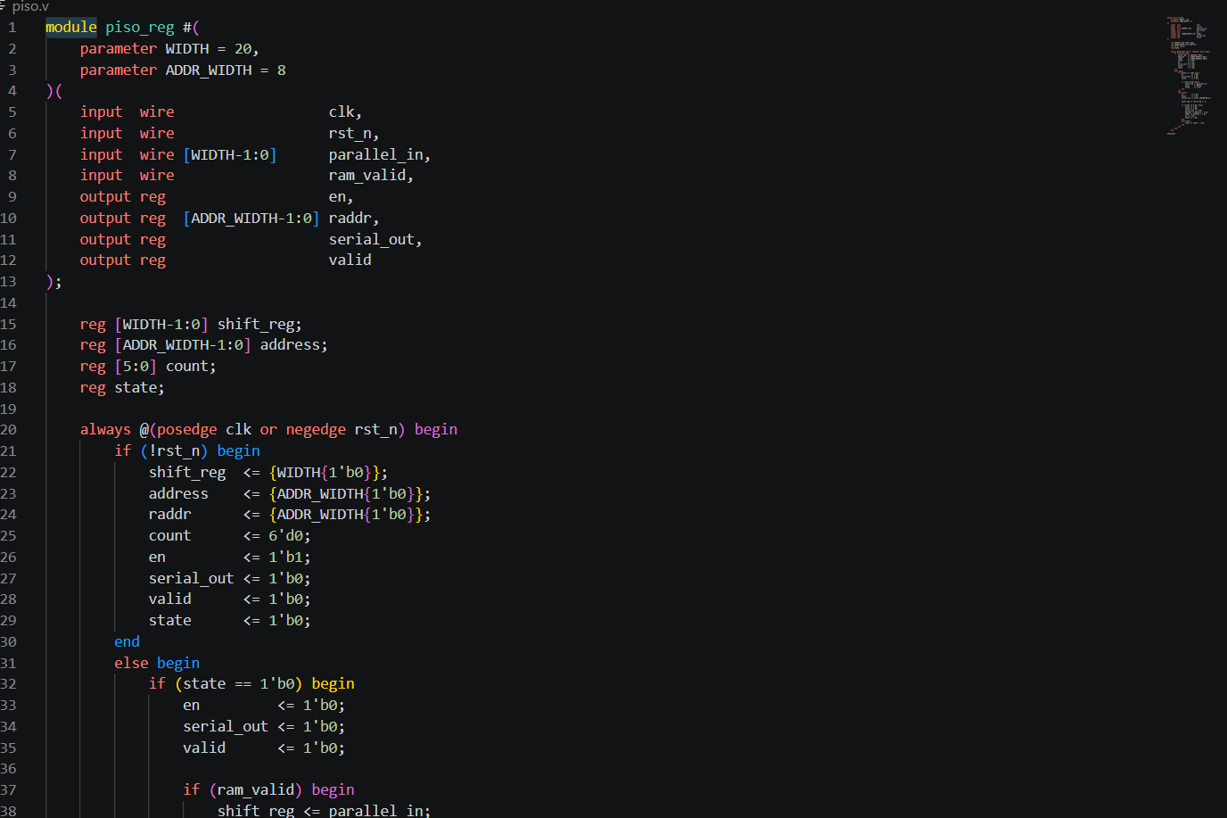
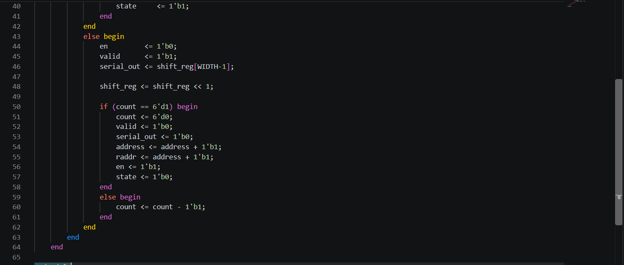

SIPO
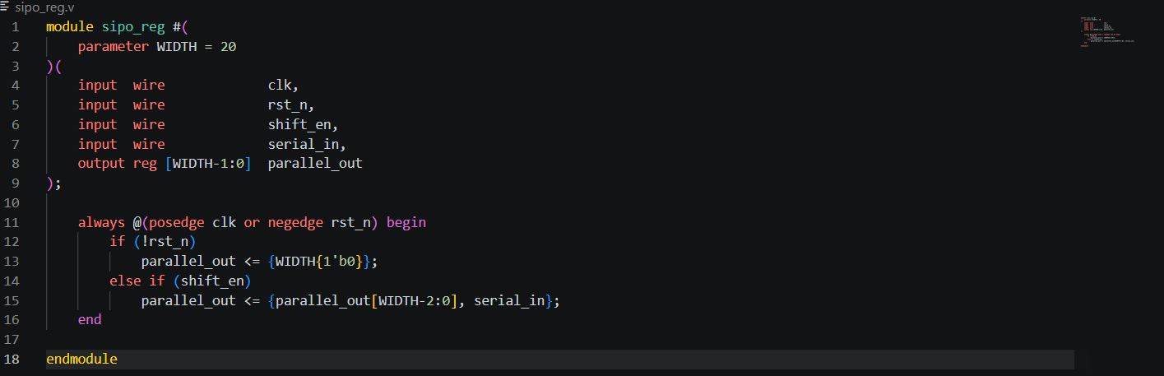
ALU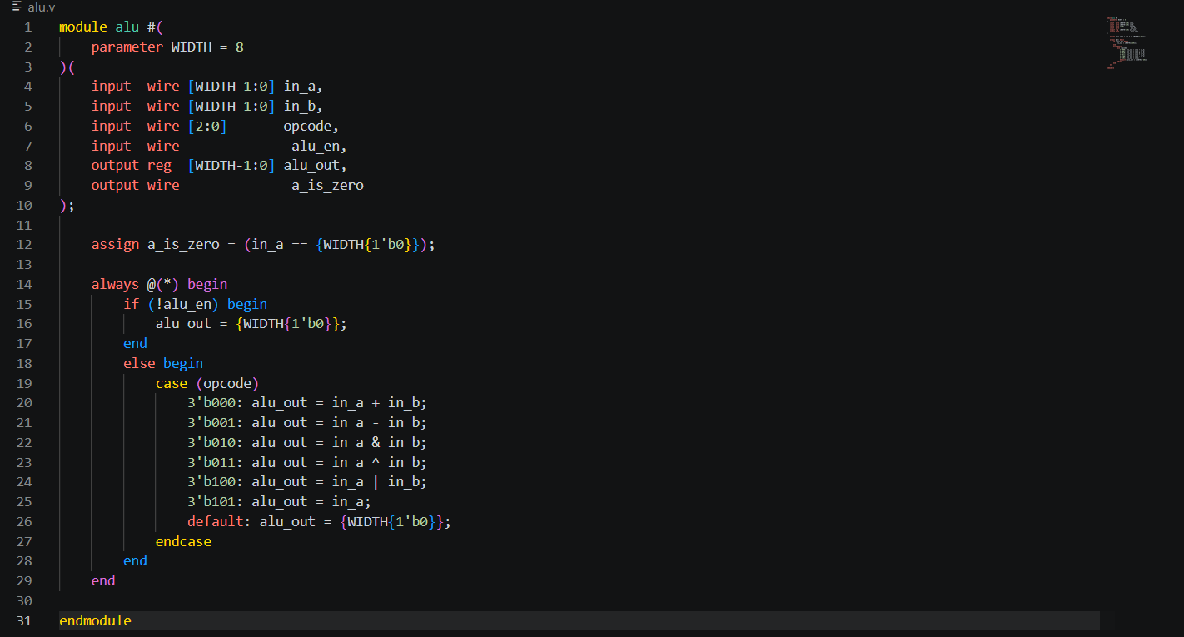
Top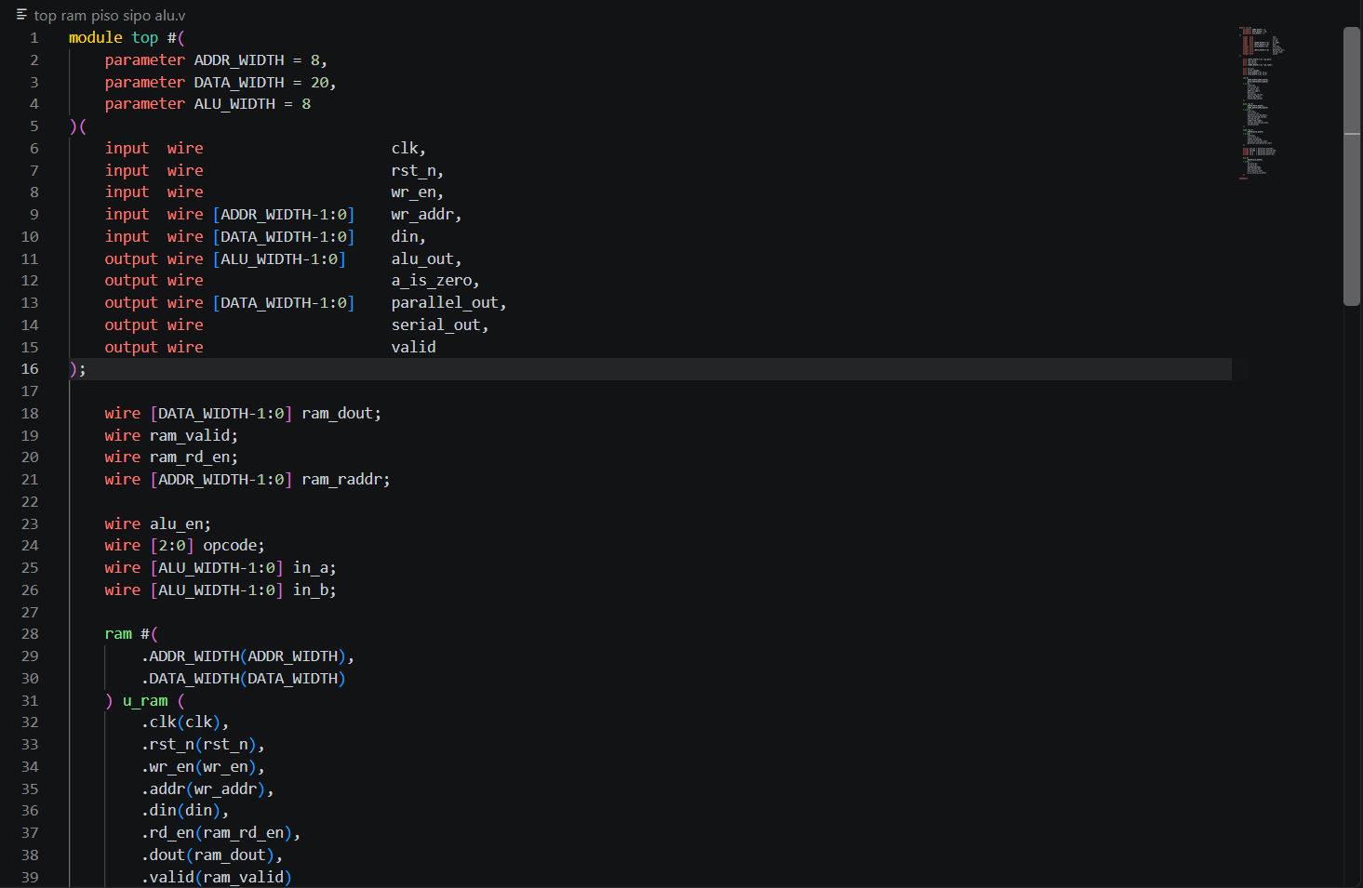
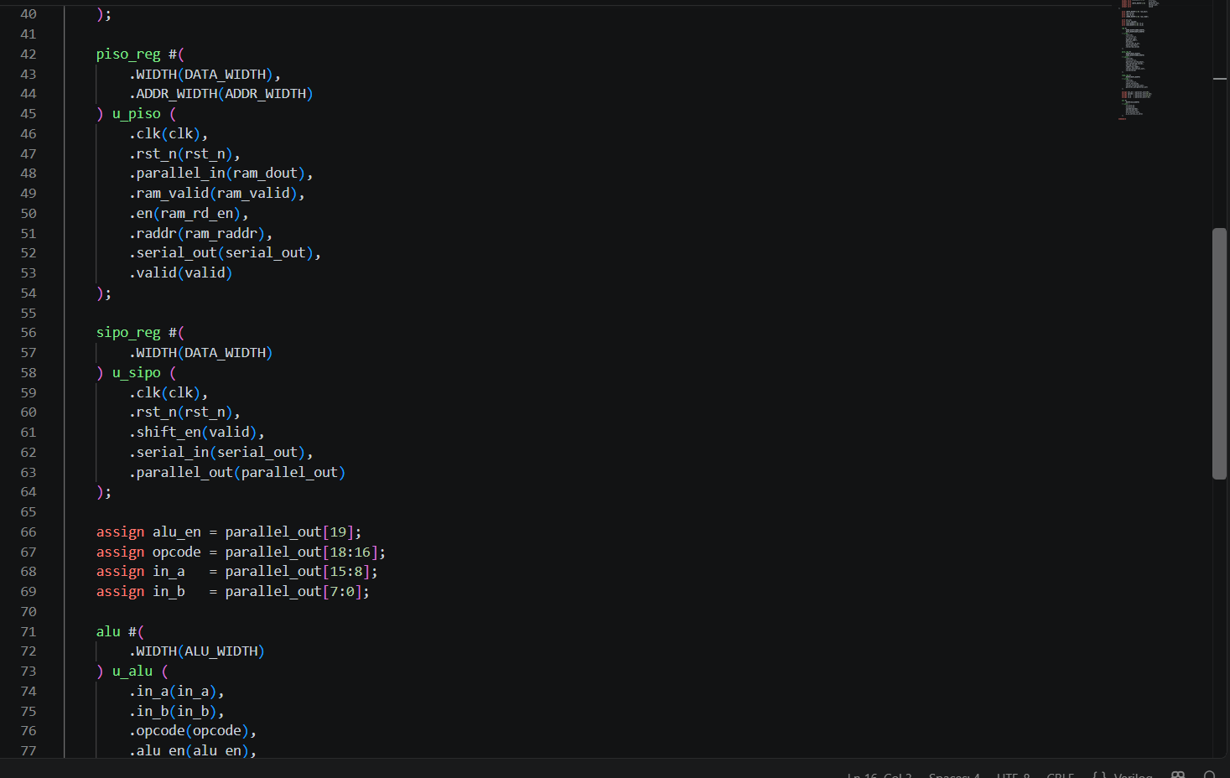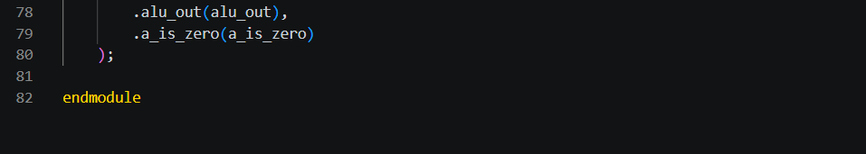
TB
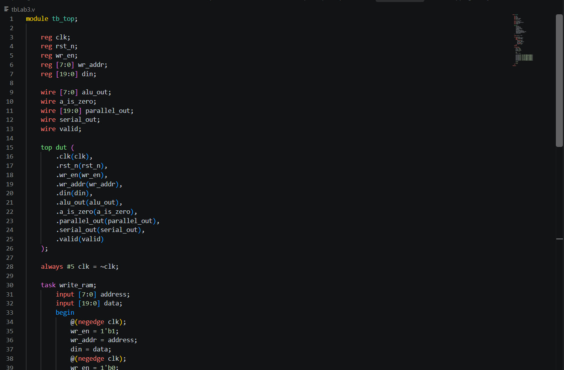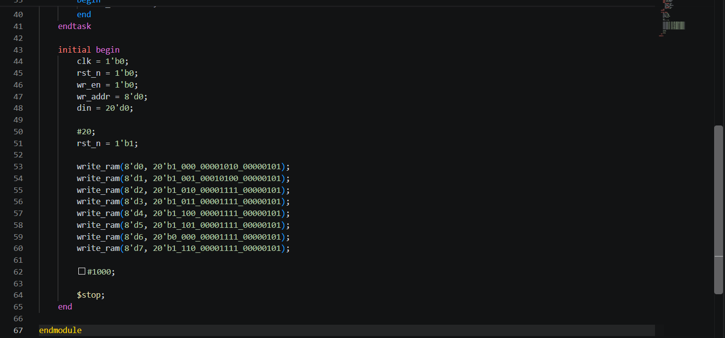

Last Lab with Eng. Mohamed (Note: I presented the rest of them to him in the session):
Overlapping sequence analyzer (mealy)
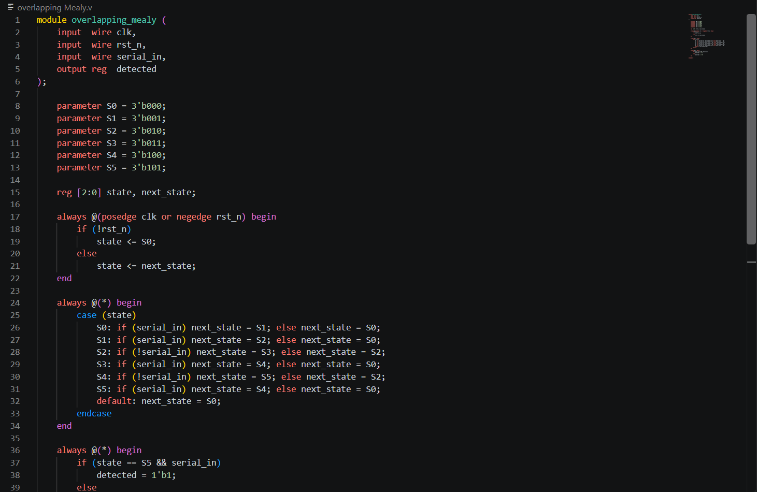
Overlapping sequence analyzer (moore)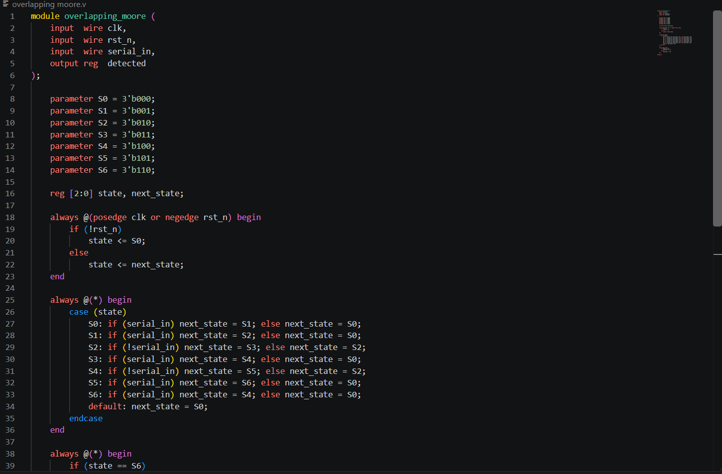
Non-overlapping sequence analyzer (mealy)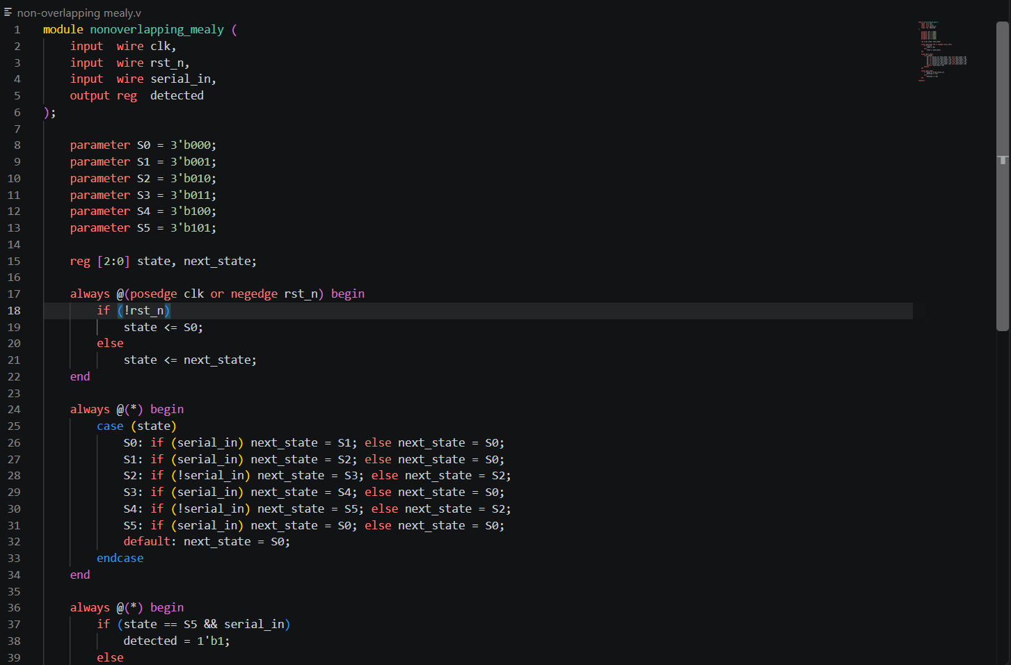 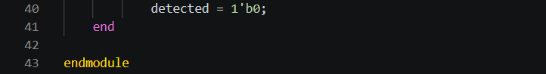
Non-overlapping sequence analyzer (moore) 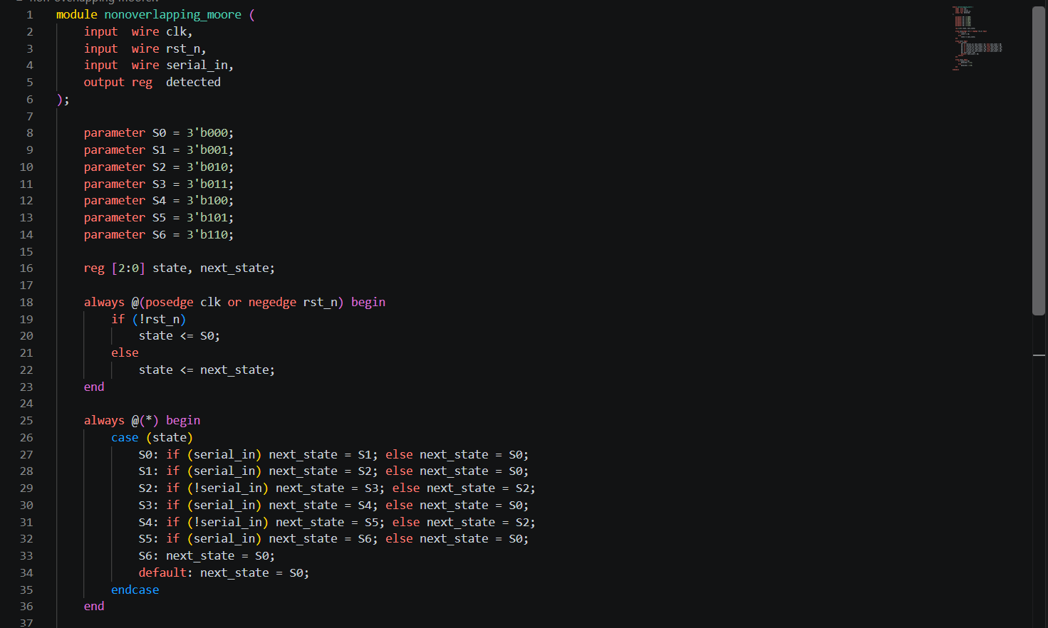 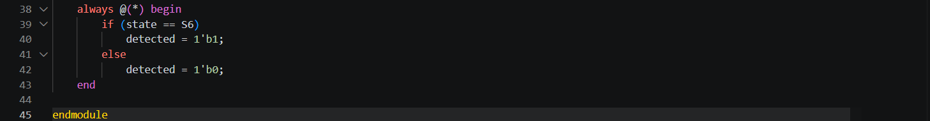

STA Task: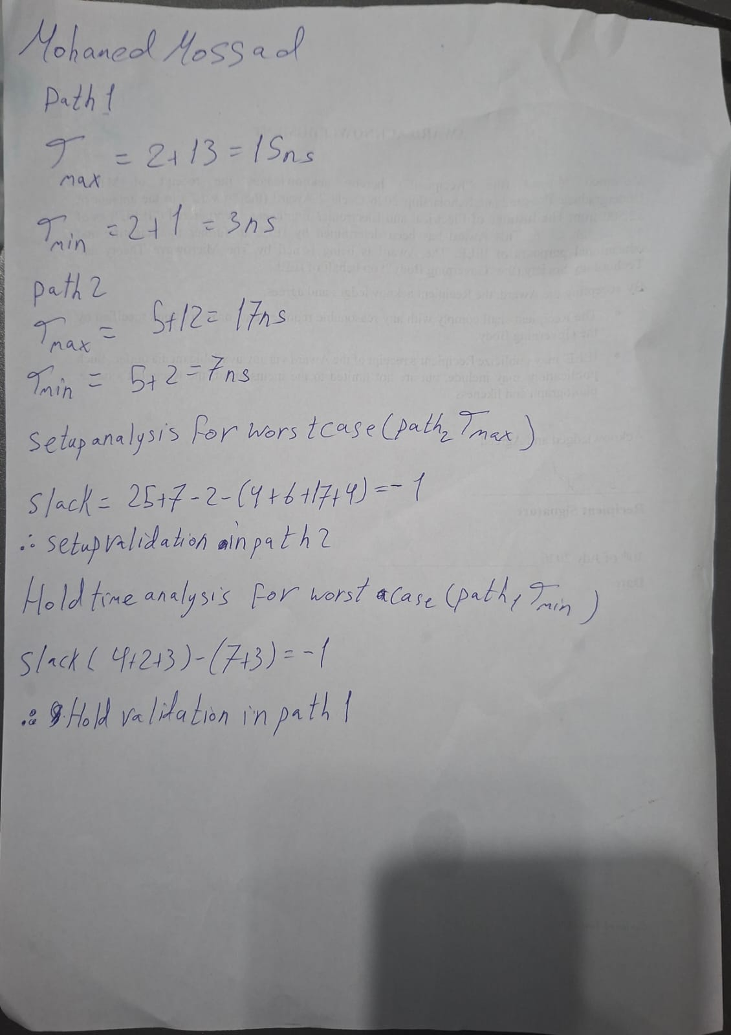
System Verilog Lab:
Q1) 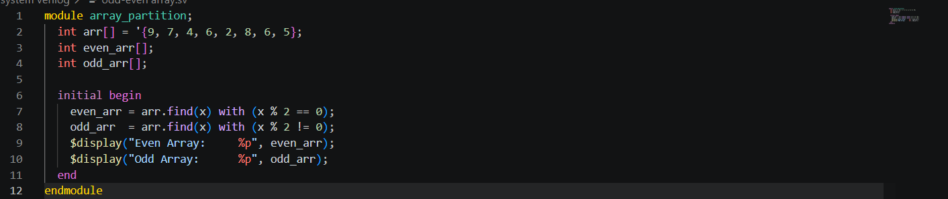
Q2) 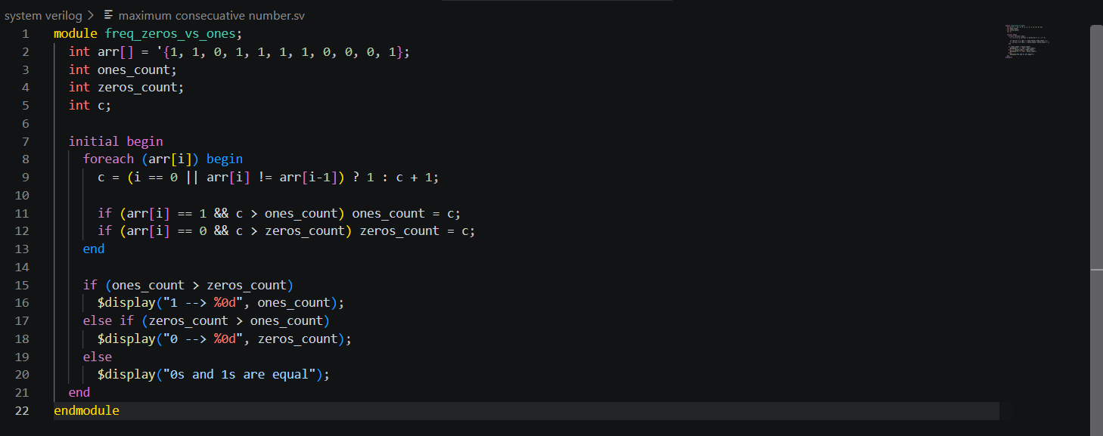
Q3) 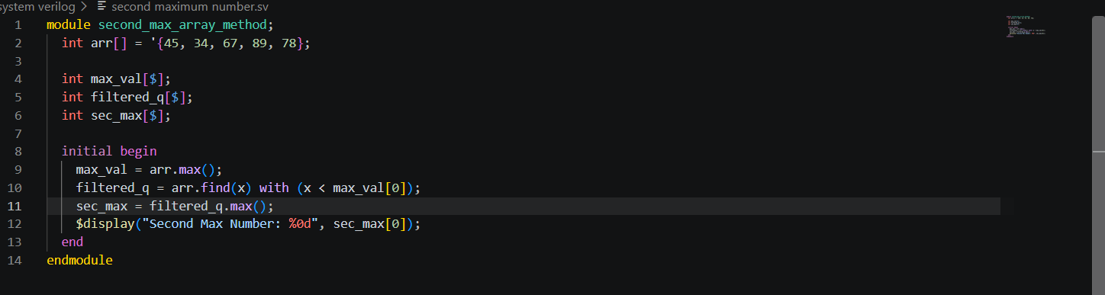
Q4) 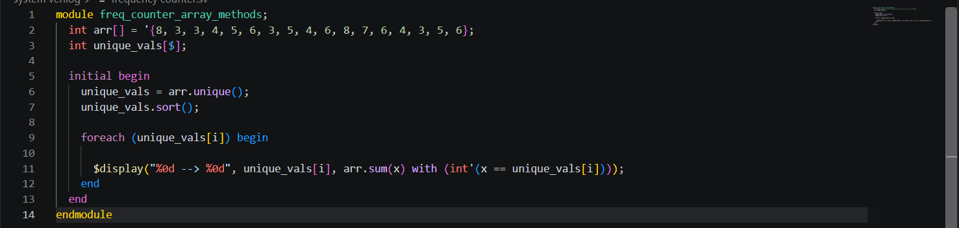

Thank you Eng. Omar for your effort I really benifited a lot.

